**LOGISTIC RIGRESSION**

**Business Problem** = ﻿ ﻿Prepare a prediction model Whether the client has subscribed a term deposit or not.

* **Name of the File: -** bank_data.csv
* **Size of the File: -** 3.2 MB
* **Data: -** ﻿45211 Observation, 32 Variable

**Exploratory data Analysis** =

* **Outliers: -**  Outliers are not presents.
* **Missing Value: -** Data don’t have Missing Values
* **Normality: -** Data are not normal
* **Output:** - Binary

1. Measuring Percentage of Subscribe and Not-subscribe in output columns

**Subscribe** - 11.7 %

**Not-Subscribe** – 88.3 %

**Model Building on Train Data = ﻿**Building model by deleting most insignificant variable at time till all model significant.

* **Summary: -**

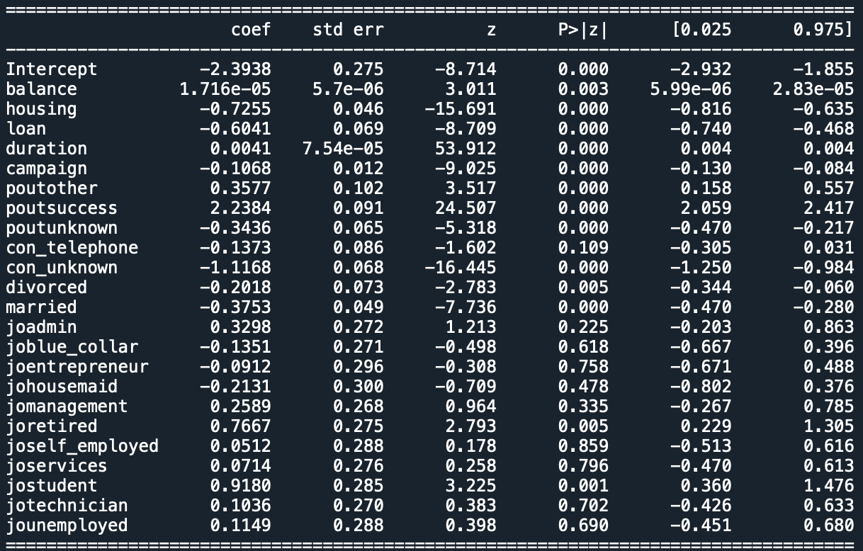

* **AIC: -** ﻿15867
* **﻿Accuracy :-** 90%
* **﻿Sensitivity :-** 98%
* **﻿Specificity: -** 31%
* **No observation: -** ﻿31647
* **﻿Df Residuals:** - ﻿31623

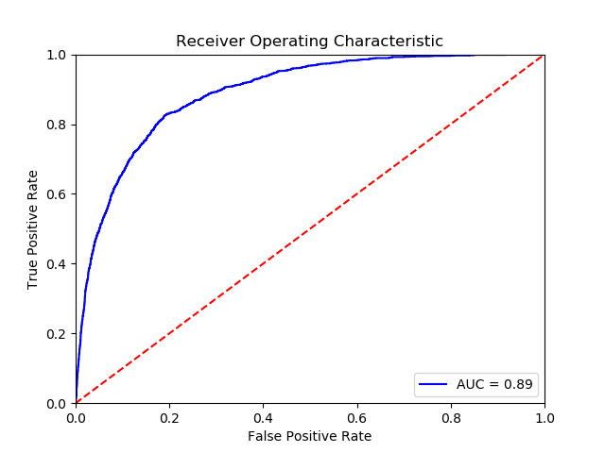**Roc Curve**: -

**Roc Curve**: - 89 %

**Python code file**: - [Bank Data Analysis.py](https://github.com/nilaydeshmukh0/Logistic-Regression-With-EDA/blob/master/Bank%20Data%20Analysis/Bank%20Data%20Analysis.py)